Sample
Order for Wendy’s Wonderful Kids® Adoption Recruitment Services

The attached Order for Wendy’s Wonderful Kids Adoption Recruitment Services is a tool for judges to ensure that children receive evidence-based adoption recruitment services.

This order can be used in jurisdictions where the Wendy’s Wonderful Kids program has expanded to be able to serve all children in the target population — including children with an adoption or another planned permanent living arrangement (APPLA) goal who lack an identified adoptive resource and who are aged nine and older, in sibling groups, or have mental or physical disabilities.

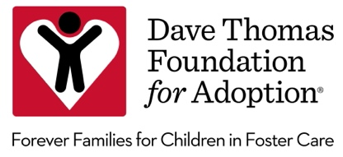

IN THE JUVENILE COURT OF COUNTY, STATE

CASE NO.: DIVISION:

IN THE INTEREST OF:

MINOR CHILD(REN).
/

ORDER FOR WENDY’S WONDERFUL KIDS ADOPTION RECRUITMENT SERVICES

THESE MATTERS having come before the Court and upon review of court files, evidence, testimony and otherwise being duly advised in the premises, and the Court finding that for children to languish in foster care longer than one year is not in the child(ren)’s best interest and violates [insert state statute re: permanency timelines], it is hereby

ORDERED that within thirty (30) days from the entry of this Order, the Director, Chief Executive Officer, or such other person with ultimate responsibility for operating the child welfare services agency copied herewith as recited below, shall refer the child(ren) for Wendy’s Wonderful Kids Adoption Recruitment Services and shall produce proof of such referral at the next scheduled hearing. The Wendy’s Wonderful Kids adoption recruiter shall be invited to all court hearings.

DONE AND ORDERED, in Chambers, at CITY, COUNTY, STATE on this day of , 20 .

JUDGE

Please Send Copies To:

Custodial Agency

Private Child Placing Agency (if applicable)

Guardian ad Litem/Court-Appointed Special Advocate

Assigned Adoption Recruiter (if applicable)

Foster Parent(s) (if notice is required by state statute)

